Code Review 

While developing this application at KentSoft, our developers followed the guidelines set in the Developer Guidelines document. We believe that the document was key to keeping a maintainable development environment which has code that members can easily read and understand.

We used Java, which was the language specified, to build the application and programmed in the same coding style specified (camel case naming, etc). However, we ran into a few software problems while using our chosen IDE, IntelliJ. This issue was resolved by our skilled versatile team of developers choosing to comfortably migrate to a different IDE called Eclipse which allowed them to complete the project with ease.

They used different elements of object orientated programming such as encapsulation and inheritance to avoid code duplication and make the code easier to maintain for future development.

We used test driven development to provide a robust application our client. This agile development pattern has allowed us to build applications efficiently but also in a way that the number of bugs are reduced. Our main form of testing was using JUnit to write test classes for our code and making sure they pass the tests.

We followed the 6-step process in our Developer Guidelines document on how to implement JUnit testing properly so that we are writing tests which actually help us find bugs.

Try and Catch was imperative in the success of this project and was used very frequently. This ensures error handling so that we know why our application crashes and to also keep running in situations where otherwise it would crash.

Method comments were also used so that each member will understand what the code is doing in the future as humans can forget easily. This ensures that members can always quickly grasp what the code written is doing so that development can happen faster.

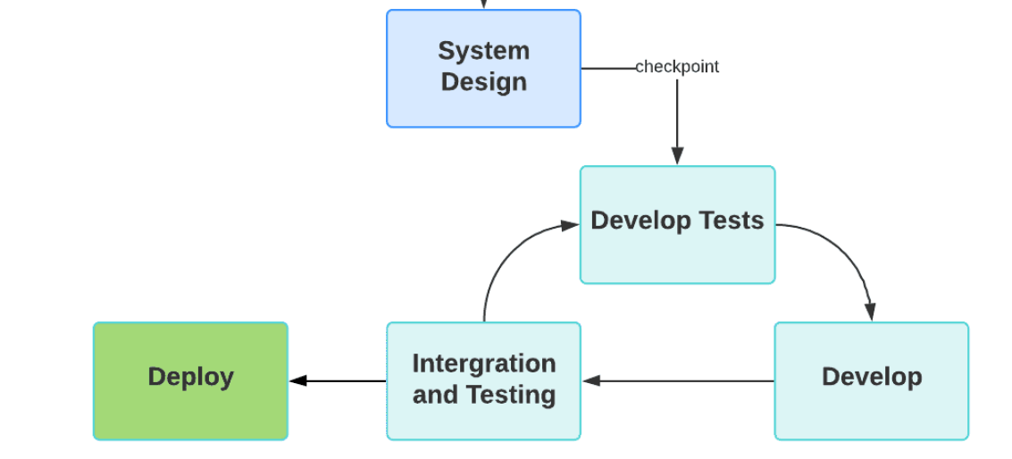

During the stages between Develop Tests, Develop and Integration and Testing we as a team will carry out reviews and update the UML class diagram as a result of the system design being changed. For example, after the first cycle of integration we review the outcome as a pair. We review our developed tests and change them according to how the application is progressing.